PlanBranch Software Proposal

Jake Gustafson

The organization currently uses Excel, Word, and handwritten updates to manage volunteer schedules. Due to the complexity of maintenance and lack of a scheduling database, the scheduler must duplicate work each week, both from format to format and from week to week. Many scheduling programs exist but are too simple to reduce work effectively in complex situations. Others are unfocused, having complex setup processes, many unused features, and unforeseeable effectiveness.

A custom software application is a ready and maintainable solution. I’ve created PlanBranch, a “web app” that allows the scheduler to do weekly and daily tasks digitally. I’ve relied on over ten years of experience with web design and databases to create a significant web app for my final project in a level two database class. I plan to maintain the program for the long term, making adjustments and providing remote or on-site support if necessary. The product will be open source to allow any software developer with appropriate training to maintain it. The data saves to the hardware on premises—the web app does not need to be exposed to the internet to work throughout the premises. PlanBranch is only a “web app” in the sense that it uses a server and a web interface to allow for expandability.

The weekly schedule automatically updates according to changes to daily schedules. The scheduler cannot know all of the specific work assignments the prior week due to day to day attendance, circumstances, and changes requested by higher-level staff. Until the scheduler adds remarks, only work assignments scheduled the prior week are visible on the weekly schedule. Using a database, the scheduler (or others if necessary) can see a single “live” schedule that includes all changes.

Without a database, any additional attribute that affects related attributes has made single-document formats less straightforward (See Figure 1). Volunteers can take part in various opportunities, but only phase two volunteers get certain types of data (such as scheduled job hunting activities). Also, volunteers have assignable permissions such as truck, kitchen, store, and staff substitute. Another dimension of complexity is limiting conditions, such as applies to volunteers prevented from doing certain tasks administratively or due to disabilities. The new system accounts for each new dimension in separate tables which are normally invisible (unless they need to be changed) but assist with automating the scheduling process.

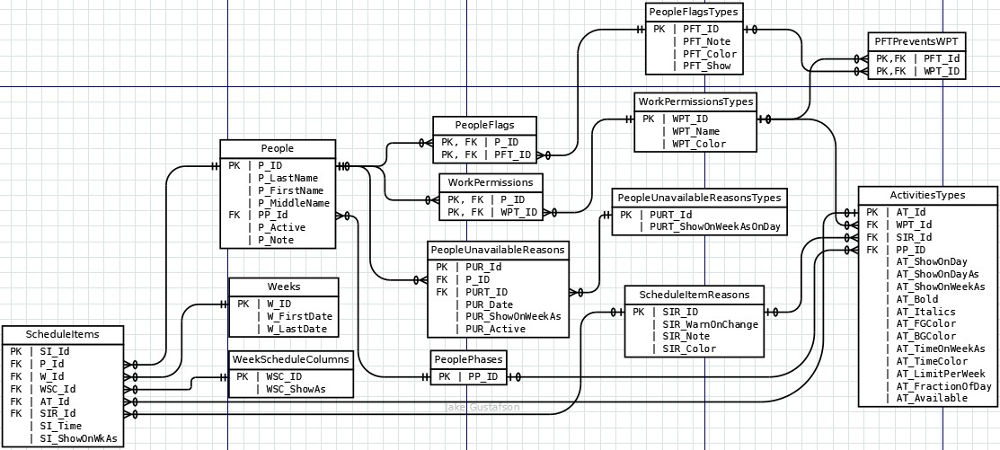

*Figure 1*. This Entity Relationship Diagram shows all of the data that affects the organization’s schedules. The scheduler (person) manages all of this information, whether creating the schedule by hand or using a database.

Experts developed the concept of relational databases over time as a natural solution to meet the needs of organizations (Coronel & Morris, 2016, p. 30). The Work Assignments document contains data duplicated on the week schedule spreadsheet. PlanBranch uses the same set of data for both formats to avoid duplicate work. Avoiding duplicate data can reduce errors and provide accurate records (Coronel & Morris, 2016, p. 20). There is a single interface for both planned and “on-the-fly” data entry. The web application can produce both schedules in print-ready formats.

The organization may wish to display the week calendar digitally in a shared office or community space. If so, the calendar would be set to refresh automatically to show work as assigned. The entry would change from “work” to something specific. Instead of the handwritten symbols “1,” “4,” “½,” “¼,” next to the word “work,” a digital display could show types of work in a way that still fit on the week schedule, such as “Lighthouse,” “crd/trash,” “clean1&2,” “clean3&4.” If desired, the week schedule could also show the further types that fall under “\*\*” rather than the handwritten “\*\*” by work. The further categories of work currently only appear as rosters on the “Work Assignment” sheet. Using database “views” ensures that computer displays not logged in as the scheduler could only see the data within the intended scope. I can create a public username that can only see such a view of the information, so the display could even be in a shared workspace or community area if necessary. In the case of a community area, the computer tower itself could be on the other side of a wall or otherwise locked up. If display screens are not necessary, then the schedules can be hidden completely from those who do not need to edit them.

Since PlanBranch is custom software, it is both simple and ready to use. The web app has only the features that the organization needs, but could expand to replace more databases or spreadsheets if necessary. My track record with open source software should give the organization confidence to adopt the new web app for scheduling, and confidence to move forward with integrating further organizational data if desired. A database-driven web app is a good fit for managing sets of data that relate to each other.

.

References

Coronel, C., & Morris, S. (2016). *Database Systems: Design, Implementation, & Management. [VitalSource Bookshelf]* (12th ed.). Retrieved from <https://bookshelf.vitalsource.com/#/books/9781337509596/>